Data Structure and Algorithms 2:
Unit 4:
Algorithm programming: Graph algorithms
4.1 NetworkX
NetworkX is one of the most interesting libraries to work with graphs. As with the libraries before, we need to import it into our code if we want to use any of its functions, classes or objects. The import will be:
import networkx as nx
Once we have the library imported, we can start working on it. NetworkX allows us to create objects like graphs, directed graphs, “multigraphs”, that are graphs that can have two or more edges between a pair of nodes, and “multidigraphs”, which are directed multigraphs. One your tasks as programmers is to select which instance of a graph is the most adequate for the use that you’re thinking about.
After creating a graph, we might need to visualize it. NetworkX provides tools for a simple visualization that are based on Matplotlib, so we will use both libraries in conjuction.
Let’s see some examples; and please remember to copy the code and try on your own computer.
Example 1: Undirected graph
- Undirected graph with two nodes
In this example, we will create an undirected graph with 2 nodes, 1 and 2, and one edge between them. It is almost the simplest graph that can exist. The graph, then, will be 𝐺=(𝑉,𝐸), 𝑉={1,2}, 𝐸={{1,2}}.

If we go step by step, the first thing that we need to do is to create an empty graph, then add the nodes, then add the edges, and finally when all is done, show it on screen.
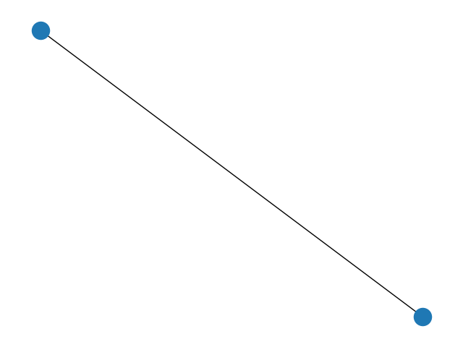
import networkx as nx
import matplotlib.pyplot as mp
#undirected graph
G = nx.Graph()
G.add_node(1)
G.add_node(2)
G.add_edge(1,2)
nx.draw(G)
mp.show()
As we can see, this figure doesn’t tell us very much. We can improve it by adding labels in the nodes, which will allow us to see which one is 1 and which one is 2. There are different ways to do that. The simplest one is to modify the line “nx.draw(G)” to:
nx.draw(G,with_labels=True)
As you can probably see when you change that line and show the result, the labels are black, inside the blue nodes, so it is a bit difficult to see. It’s left as an exercise for you to find how to change the colour of both to have a clearer graph.
- Define a list of nodes or edges
The above code allowed us to create a simple graph by adding edges one by one, but of course in more complicated graphs this can be tedious. So, another way of doing that would be the following:
import networkx as nx
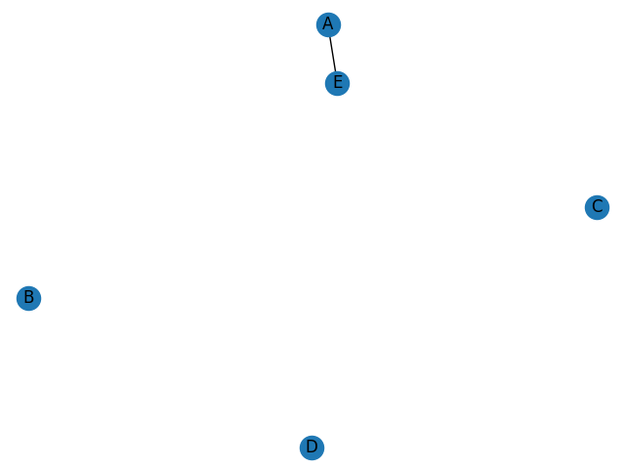
import matplotlib.pyplot as mp
#another undirected graph
G = nx.Graph()
nodes=["A","B","C","D","E"]
G.add_nodes_from(nodes)
list_of_edges=[("A","E")]
G.add_edges_from(list_of_edges)
nx.draw(G,with_labels=True)
mp.show()
As you can see, I can define a list of nodes or edges and add them all together to the graph. This will mean also that we can receive this list from somewhere – another function, for example- and then add it to a graph.
- Add weight to the edges
Lastly, if we wanted to add some weight to these edges, we would use the following code.
Because of how NetworkX works, it is easier to define a layout for the graph (different layouts can be found in the documentation) and then separately add the nodes, edges, labels of the nodes and labels of the edges independently.
import networkx as nx
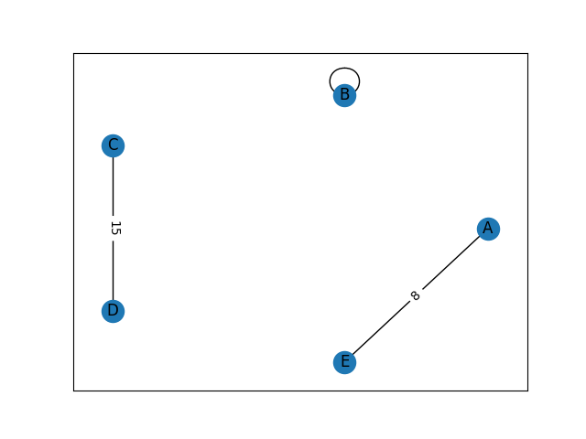
import matplotlib.pyplot as mp
#undirected weighted graph
G = nx.Graph()
nodes=["A","B","C","D","E"]
G.add_nodes_from(nodes)
G.add_edge("A","E", weight=8)
G.add_edge("B","B")
G.add_edge("C","D", weight=15)
#Layout set to circular
pos= nx.circular_layout(G)
# Nodes
nx.draw_networkx_nodes(G,pos
# Edges
nx.draw_networkx_edges(G, pos)
# Node labels
nx.draw_networkx_labels(G, pos)
# Edge labels
edge_labels = nx.get_edge_attributes(G, "weight")
nx.draw_networkx_edge_labels(G, pos, edge_labels)
mp.show()
There are other functions in NetworkX that can show the same results; for example, using the function “add_weighted_edges_from”. Please take some time to research the documentation and experiment which functions are the most comfortable for you to use, be it in terms of layout, adding of the edges, etc.
From now on, the examples will be very simple, but you are encouraged to customize them with the expressions to add labels, colours, etc., that we have seen or you have researched.
- Example 1.1: Multigraph
What NetworkX calls “MultiGraph” is the object that allows two or more edges to exist within the same pair of nodes. We will not use it in this module, but it’s just for your information. For example, if we have the following graph:
We see that between A and B there are two edges. Weights are added for easiness of comparison, but are not mandatory.
If we use the function “Graph” as previously, the attributes of the edge will be updated to the latest one. But if we want to have two distinct edges between A and B, we need the MultiGraph function.
However, bear in mind that NetworkX has not implemented a drawing function using Matplotlib. Common workarounds are using another library for graph visualization (Graphviz) or draw nodes and edges using the functions we have seen but put them together in a Matplotlib image.
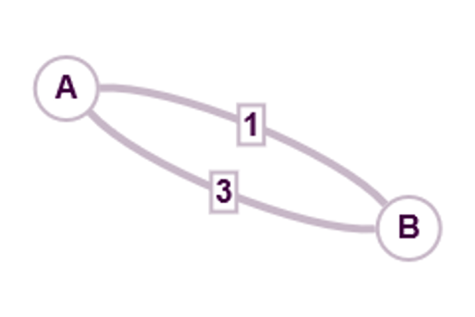
import networkx as nx
import matplotlib.pyplot as mp
#undirected graph
G = nx.MultiGraph()
nodes=["A","B"]
G.add_nodes_from(nodes)
G.add_edge("A","B", weight=1)
G.add_edge("A","B", weight=3)

Example 2: Directed graph
Directed graphs are the type of graphs where edges have a direction.
Where the graph is 𝐺=(𝑉,𝐸),𝑉={𝐴,𝐵},𝐸={(𝐴,𝐵)}
For example, if the graph is 𝐺=(𝑉,𝐸),𝑉={𝐴,𝐵},𝐸={(𝐴,𝐵)}, we could code as the following:

import networkx as nx
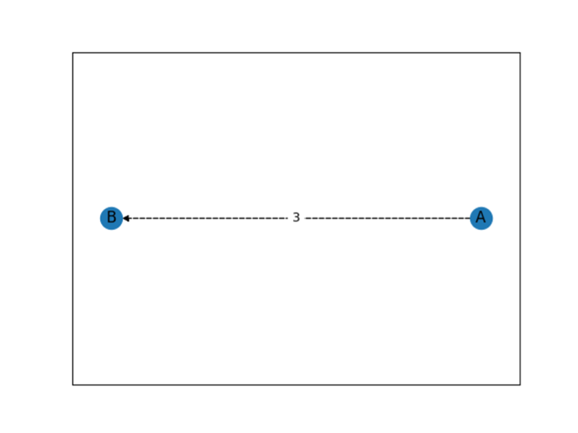
import matplotlib.pyplot as mp
#undirected graph
G = nx.DiGraph()
nodes=["A","B"]
G.add_nodes_from(nodes)
G.add_edge("A","B", weight=3)
#Layout set to circular
pos= nx.circular_layout(G)
# Nodes
nx.draw_networkx_nodes(G,pos)
# Edges
nx.draw_networkx_edges(G, pos, style=['dashed'])
# Node labels
nx.draw_networkx_labels(G, pos)
# Edge labels
edge_labels = nx.get_edge_attributes(G, "weight")
nx.draw_networkx_edge_labels(G, pos, edge_labels)
mp.show()
Example 2.1: Directed multigraph: As before, if we want to have two or more edges connecting the same pair of nodes in the same direction, we need to use the MultiDiGraph function. This is just a mention so you know it exists, but we will not use it in this module.
4.2 Programming graph algorithms
In this section we will learn how to program different algorithms in graphs and trees. Mathematically, trees are a more restrictive versions of graphs; specifically, they are acyclic connected graphs.
You will explore and practise using:
- Depth-first search
- Breadth-first search
- Dijkstra’s algorithm
Although some of the libraries (including NetworkX) have some native functions that have implemented these algorithms, and in your usual work life you wouldn’t be expected to implement one from 0 necessarily, in this module we will create them from scratch – or almost – to be able to understand what they do properly.
Depth-First Search (DFS) is an algorithm that allows us to traverse graphs. Some of its uses that we saw in DSA-1 are for finding nodes in rooted trees and for building a tree from a connected graph.
We will program a searching DFS using recursivity. In this case, we want to search for a target node in our rooted tree. The algorithm would go as follows:
Descriptive DFS algorithm
We choose our root node. From this root node, we traverse the tree away from the root, by choosing arbitrarily one of the edges incident (i.e., “connected”) to that node. For each edge, we check wether the node incident to that edge is our target node. If yes, the algorithm ends. If no, we continue traversing the algorithm checking if we reach our target and adding one edge at a time until we can’t add any more edges to this path or we find the target node. If no more edges can be added, we backtrack (i.e., we go to the previous node) and look for any incident edges that connect that node with previous unvisited nodes. If all edges have been visited and we haven’t found our target, it doesn’t exist in our tree.
Note that we never stated which of the incident edges must be visited first, as this is not a requirement for DFS. DFS can be done in any tree, it does not need to be binary, so “left” and “right” might not make sense. If we want to include some other constraints, we need to be very careful with the position of the nodes in the graph as well.
For this searching algorithm to work, we need to ensure that we have a tree. Note that if we want to use DFS as a constructor for building a tree from a graph, this is not the case, and we can start from a graph.
For testing purposes, we can use the random_labeled_rooted_tree function to create a tree. If a graph is provided, to use the DFS as a searching algorithm, we must ensure it is a tree. The function is_tree(G) will return True if G is a tree, and it is an easy check to do before we go into DFS.
Breadth-First Search (BFS) is another graph-traversing algorithm. Like its “sibling” DFS, it can be used to look for a certain node in a tree or to create a tree from a graph, amongst others.
Descriptive BFS algorithm
In BFS, we also start at the root node. Then we look at all the children from the node, in turn. If none of them is the target, we look at the children of the children; what we are doing is visiting all the nodes in the same level, in turn, until there are no more nodes in that level. Only then we will go to the next level, and visit all the nodes in that level as well, until we either find our target or visit all the nodes.
BFS does not need to backtrack, is it is easier by doing an adjacency search. Remember that adjacent nodes can also be called “neighbours”.
Dijkstra’s algorithm is an algorithm that allows us to find the shortest length between two nodes in a simple weighted connected undirected graph.
Dijkstra’s algorithm
We decide our beginning and end nodes (usually called “a” and “z” for easiness of understanding). To our beginning node, “a”, we give a label of 0. All the other nodes have labels with an infinite, as we haven’t visited any of them yet. The label represents the distance from “a”.
From each node, “x”, we process it as follows:
First, we will check the incident edges to as yet unprocessed nodes. The unprocessed neighbouring nodes get their labels updated with the minimum distance, which can be either their current label or the sum of the weight of the edge coming from the node “x” plus the label of “x”. Once all the incident edges have been updated, we pick a new node, “y”, which is the unprocessed node with the lowest label. “x” is now in the processed node list, so we can’t update its label anymore.
Dijkstra’s algorithm can be modified to also save the shortest path and not give just the length. It can also easily be upgraded to give the shortest path from our beginning node to any other node in the graph. This version is downloadable below.
When coding, the “infinite” label is impossible. To resolve this, we can use a label of an “impossible” distance value; for example, a string or a negative number. Keep in mind that then the comparison is not straightforward, as we need to treat that differently from the rest of comparisons, so we might need to add an extra check.

